A+ - Troubleshooting and Helpdesk

PROGRAM: CompTIA A+
ASSESSMENT CODE: AP-A1
NAME: VISHAL SARENA

Section A — Concept Application

Question 1: Explain the process of selecting a compatible motherboard, CPU, RAM, and storage device for a new office workstation, and justify how you would confirm they will work together.
Answer:
- Select the Motherboard
  - Choose a motherboard suitable for office use.
  - Check its CPU socket, RAM type, and storage support.
- Select the CPU
  - Choose a suitable CPU such as Intel Core i5 or AMD Ryzen 5.
  - Make sure the CPU socket matches the motherboard socket.
- Select the RAM
  - Choose 8 GB or 16 GB RAM for normal office work.
  - Check that the RAM type, such as DDR4 or DDR5, is supported by the motherboard.
- Select the Storage Device
  - Choose a 512 GB SSD for fast booting and file access.
  - Check that the motherboard supports the selected SATA or NVMe M.2 SSD.
- Confirm Compatibility
  - Check the motherboard manufacturer's CPU compatibility list.
  - Check the supported RAM type, speed, and maximum capacity.
  - Check the available M.2/SATA slots for the storage device.
  - Confirm that all four components are compatible before purchasing.

Example:
Component | Selection | Compatibility Check
Motherboard | B760 | Supports Intel LGA1700 CPU and DDR4/DDR5 depending on model
CPU | Intel Core i5 | Must use matching LGA1700 socket
RAM | 16 GB DDR4 | Motherboard must support DDR4
Storage | 512 GB NVMe SSD | Motherboard must have an M.2 NVMe slot

Question 2: Explain the differences between HDD, SSD, and NVMe storage, and recommend the most suitable option for this workload, giving technical reasons for your choice.

Feature | HDD | SSD | NVMe SSD
Technology | Uses spinning magnetic disks and a mechanical read/write head | Uses NAND flash memory with no moving parts | Uses NAND flash memory and communicates through PCIe
Speed | Slow | Faster than HDD | Fastest of the three
Interface | SATA | Usually SATA | PCIe through NVMe
Boot/Application Loading | Slow | Fast | Very fast
Moving Parts | Yes | No | No
Noise | Makes some mechanical noise | Silent | Silent
Power Consumption | Higher | Lower | Generally low to moderate
Cost per GB | Lowest | Higher | Usually higher than HDD
Durability | More affected by physical shock | More resistant to shock | More resistant to shock

Recommended Option: SSD
For employees who mainly use Microsoft Office, web browsers, email, spreadsheets, presentations, and other productivity applications, I would recommend a standard SSD, preferably a SATA SSD, as a practical choice.

Question 3: Explain the role of the GPU and the cooling system in maintaining performance and stability under this kind of sustained load.

When a workstation runs graphics-intensive design software for several hours, the GPU (Graphics Processing Unit) and cooling system are important for maintaining good performance and system stability.

- Role of the GPU:
The GPU is responsible for processing and rendering graphics. Design applications such as CAD, 3D modeling, video editing, and graphic design can use the GPU to perform complex graphical calculations.
The GPU helps by:
- Rendering images and 3D models quickly.
- Processing graphics, textures, lighting, and visual effects.
- Reducing the graphics-processing workload on the CPU.
- Providing smoother performance when working with large or complex designs.
- Using dedicated VRAM (Video RAM) to store graphics data for quick access.
A suitable GPU with enough processing power and VRAM helps the workstation maintain consistent performance during long design sessions.

2. Role of the Cooling System
Running the GPU and CPU for several hours generates significant heat. The cooling system removes this heat and keeps components within their safe operating temperatures.
A typical cooling system may include:
- CPU heatsink and fan to remove heat from the processor.
- GPU heatsink and fans to cool the graphics card.
- Case fans to move hot air out and cool air into the workstation.
- Thermal paste to improve heat transfer between the processor and heatsink.

3. Why Cooling Is Important During Sustained Load
- If the temperature becomes too high, components can automatically reduce their operating speed. This is called thermal throttling. It can cause slower application performance and reduced responsiveness.
- Excessive heat over a long period can also cause system instability, crashes, or reduced component lifespan.
- Therefore, effective cooling allows the GPU and CPU to operate at their intended performance levels for longer periods and helps prevent overheating.
Question 4: Explain why hardware compatibility matters when assembling a computer, and identify potential issues that could arise from incompatible components.

Hardware compatibility is important because all computer components must work together correctly. When components are purchased from different vendors, compatibility should be checked before assembling the PC.
Why Hardware Compatibility Matters
- Correct Physical Fit
  - Components must physically fit inside the computer case.
  - For example, the motherboard size must match the supported case form factor.
- CPU and Motherboard Compatibility
  - The CPU must use the correct socket supported by the motherboard.
  - The motherboard BIOS/UEFI must also support the selected processor.
- RAM Compatibility
  - RAM must be compatible with the motherboard in terms of DDR generation, capacity, speed, and supported configuration.
  - For example, DDR4 and DDR5 are not interchangeable.
- Power Supply Compatibility
  - The PSU must provide enough wattage for the CPU, GPU, drives, and other components.
  - It must also have the correct power connectors.
- GPU Compatibility
  - The graphics card must have a compatible motherboard interface, normally PCIe.
  - There must also be enough physical space in the case and sufficient PSU capacity.
- Storage Compatibility
  - Storage devices such as SATA SSDs, HDDs, and M.2 NVMe SSDs must be supported by the motherboard.
  - Some M.2 slots support only certain interfaces.
- Cooling Compatibility
  - The CPU cooler must be compatible with the CPU socket.
  - The cooler must also fit inside the case and provide sufficient cooling capacity.
Problems Caused by Incompatible Components
- Computer may not boot or may fail POST.
- CPU may not work if its socket or BIOS is unsupported.
- RAM may not be detected or the system may become unstable.
- GPU may not fit physically inside the case.
- Power supply may be insufficient, causing shutdowns or crashes.
- Storage drive may not be detected if the motherboard does not support its interface.
- Overheating may occur if the cooling system is incompatible or inadequate.
- Performance may be reduced if components cannot operate at their supported speeds.
- System crashes or errors can occur because of unstable or incompatible hardware.
- Components can potentially be damaged if incorrect power connections or unsuitable electrical specifications are used.

Question 5: Explain how you would choose an appropriately rated PSU for this build and describe the safety and connection checks you would carry out before powering it on.

Answer:
1. Choosing an Appropriate PSU
- Calculate total power requirements
  - Check the power consumption of the CPU, GPU, motherboard, storage drives, fans, and other components.
  - Add their power requirements to estimate the total system load.
- Add extra power headroom
  - Choose a PSU with additional capacity above the estimated load.
  - This provides room for power spikes, future upgrades, and sustained workloads.
- Check PSU wattage
  - Select a suitable wattage such as 550 W, 650 W, 750 W, or higher, depending on the components.
  - A high-performance GPU generally requires a higher-wattage PSU.
- Check the +12V rail
  - The +12V rail supplies power to major components such as the CPU and GPU.
  - Make sure it can provide sufficient current for the system.
- Check power connectors
  - Ensure the PSU has the required connectors, such as:
    - 24-pin ATX for the motherboard
    - 4/8-pin CPU EPS connector
    - PCIe/12VHPWR or 12V-2x6 connector as required by the GPU
    - SATA power connectors for storage devices
- Choose a quality PSU
  - Use a reliable PSU from a reputable manufacturer.
  - An appropriate 80 PLUS efficiency rating can help reduce wasted power and heat.
2. Safety and Connection Checks Before First Boot
- Turn off and unplug the PSU
  - Make sure the PSU is switched off and disconnected from AC power while making connections.
- Check the motherboard connection
  - Firmly connect the 24-pin ATX connector to the motherboard.
- Connect CPU power
  - Connect the required 4/8-pin EPS CPU power connector near the CPU socket.
- Connect GPU power
  - Connect the correct PCIe/GPU power connector to the graphics card.
  - Make sure the connector is fully inserted.
- Connect storage devices
  - Connect SATA power cables to SATA HDDs or SSDs.
  - NVMe M.2 drives normally receive power through the motherboard and do not require a separate SATA power cable.
- Check cable connections
  - Ensure every connector is fully seated and properly aligned.
  - Never force a connector into the wrong socket.
- Check modular PSU cables
  - If using a modular PSU, use only the cables supplied for that PSU. Modular cables from another PSU may have different wiring.
- Check for loose objects
  - Make sure there are no loose screws, tools, or metal objects inside the case.
- Check cable routing
  - Keep cables away from fans and other moving parts.
  - Ensure cables are not blocking airflow.
- Check motherboard mounting
- Confirm the motherboard is correctly mounted on the required standoffs and is not touching the case directly.
- Final inspection
- Check the CPU cooler, RAM, GPU, storage, and all required power connections before turning on the system.
- Power on safely
- Connect the PSU to a properly grounded electrical outlet.
- Switch the PSU on and press the PC's power button.
- Check for normal POST, display output, fan operation, and error indicators.

Question 6: Explain the checks you would perform to confirm the system passes POST successfully, and what you would do if it did not.

Answer:
Checks to Confirm Successful POST
- Power On
  - Turn on the computer and check that it starts normally.
- Check Power LED
  - Make sure the power indicator turns on.
- Check Fans
  - Confirm that the CPU, GPU, and case fans are running normally.
- Check Beep Codes
  - Listen for beep sounds from the motherboard.
  - Error beep patterns may indicate hardware problems.
- Check Diagnostic LEDs
  - Check the motherboard's CPU, DRAM, VGA, and BOOT LEDs.
  - No error LED should remain on after successful POST.
- Check Display
  - Confirm that the monitor shows the manufacturer logo or BIOS/UEFI screen.
- Enter BIOS/UEFI
  - Press Delete or F2 during startup.
  - Check that the main hardware components are detected.
- Check RAM
  - Confirm that the correct amount of installed RAM is recognized.
- Check CPU
  - Verify that the correct CPU is detected.
- Check Storage
- Confirm that the SSD, HDD, or NVMe drive is detected.
11.Check Boot Process
- Confirm that the computer continues from POST and successfully starts the operating system.

If the System Does Not Pass POST
- Power Off
  - Turn off and unplug the computer before checking internal components.
- Check Power Cables
  - Check the 24-pin motherboard and CPU power connectors.
- Reseat RAM
  - Remove and reinstall the RAM.
  - Test with one RAM module at a time if needed.
- Check GPU
  - Reseat the graphics card.
  - Check that its power cables are connected properly.
- Check Diagnostic LEDs/Beep Codes
  - Use motherboard indicators or beep codes to identify the possible faulty component.
- Check CPU and Cooler
  - Make sure the CPU is installed correctly and the CPU cooler is connected.
- Check for Short Circuits
  - Look for loose screws, incorrect motherboard standoffs, or loose cables.
- Clear CMOS
  - Reset BIOS/UEFI settings by clearing the CMOS according to the motherboard instructions.
- Use Minimal Hardware
  - Disconnect unnecessary devices and test using only the CPU, motherboard, one RAM module, PSU, and display.
- Replace Faulty Component
- If a component is confirmed to be defective, replace it with a compatible working component.

Section B — Practical Coding Tasks

Task 1: Component Identification & Functions
- Identify and describe the function of the motherboard, CPU, RAM, GPU, storage device, and cooling system.
- Note the make/model or key specification of each component where visible.
- Present the findings as a labeled component list or table.

ANSWER:

- Motherboard
Get-CimInstance Win32_BaseBoard | Select-Object Manufacturer, Product, Version

Manufacturer Product Version
------------ ------- -------
Dell Inc. 03P5X2 A00

- CPU
Get-CimInstance Win32_Processor | Select-Object Name, NumberOfCores, NumberOfLogicalProcessors, MaxClockSpeed

Name NumberOfCores NumberOfLogicalProcessors MaxClockSpeed
---- ------------- ------------------------- -------------
11th Gen Intel(R) Core(TM) i7-1185G7 @ 3.00GHz 4 8 1805

- RAM
Get-CimInstance Win32_PhysicalMemory | Select-Object Manufacturer, PartNumber, Capacity, Speed, SMBIOSMemoryType

Manufacturer : 80AD000080AD
PartNumber : HMAA2GS6CJR8N-XN
Capacity : 17179869184
Speed : 3200
SMBIOSMemoryType : 26

- GPU
Get-CimInstance Win32_VideoController | Select-Object Name, AdapterRAM, DriverVersion

Name AdapterRAM DriverVersion
---- ---------- -------------
Intel(R) Iris(R) Xe Graphics 2147479552 32.0.101.7088

- Storage
Get-PhysicalDisk | Select-Object FriendlyName, MediaType, Size, HealthStatus, BusType

FriendlyName : SATA SSD
MediaType : SSD
Size : 256060514304
HealthStatus : Healthy
BusType : SATA

- Cooling System
Get-CimInstance Win32_Fan | Select-Object Name, Status, ActiveCooling

Name Status ActiveCooling
---- ------ -------------
Cooling Device OK True

Task 2: Motherboard Ports & Socket Identification
- Identify and label all major motherboard ports (SATA, power, USB headers, etc.).
- Identify all expansion slots (PCIe, M.2, etc.) and their purpose.
- Identify the CPU socket type and note which CPU families are compatible with it.
- Photograph or diagram the motherboard with labels

ANSWER:

1. Identify and Label All Major Motherboard Ports
1. 24-Pin ATX Power Connector
The 24-pin ATX connector supplies the main power from the PSU to the motherboard.
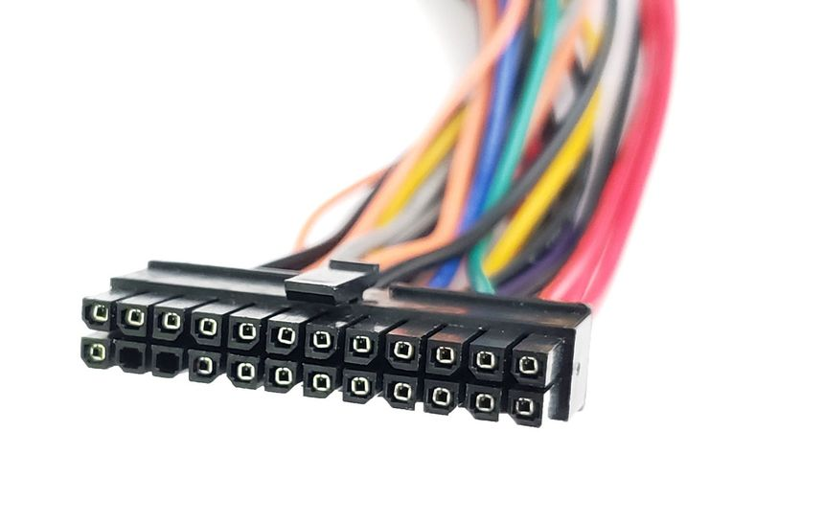
2. 4/8-Pin CPU Power Connector
The CPU power connector supplies additional power from the PSU directly to the processor.
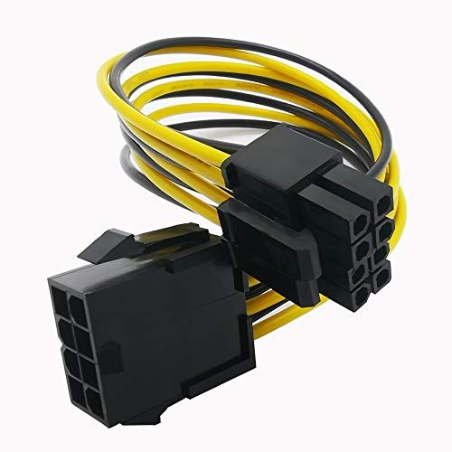
3. SATA Ports
SATA ports are used to connect SATA storage devices such as HDDs and SATA SSDs.
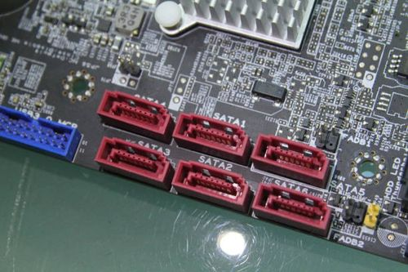
4. USB Headers
USB headers are internal motherboard connectors used to connect the computer case's front USB ports.
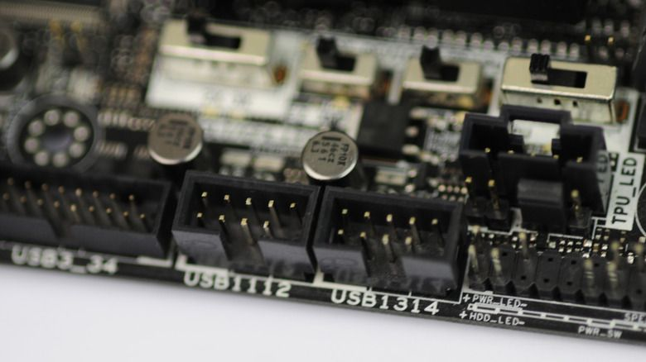

6. CPU Fan Header
The CPU fan header provides power and speed control for the CPU cooling fan.
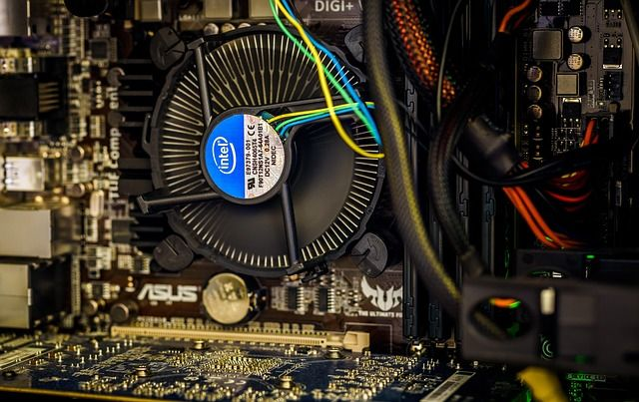
7. Audio Ports
Audio ports are used to connect speakers, headphones, microphones, and other audio devices.
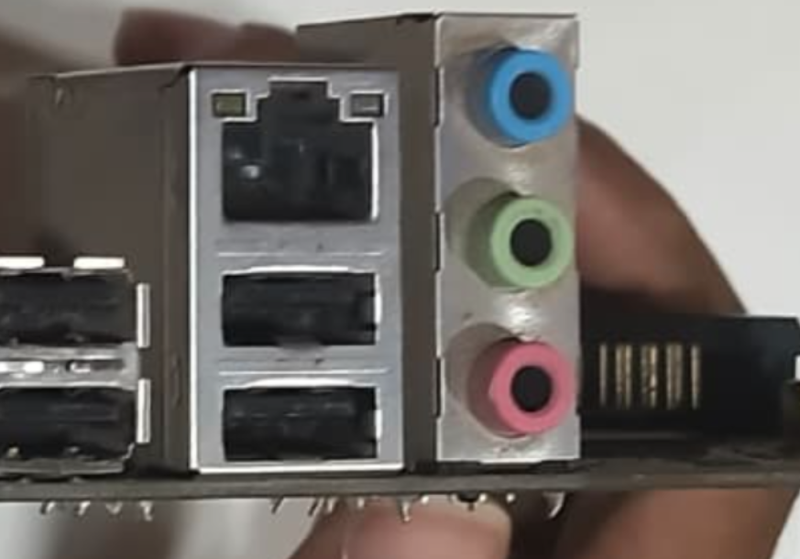
8. HDMI/DisplayPort
HDMI and DisplayPort can be used to connect a monitor when the motherboard and CPU support integrated graphics.
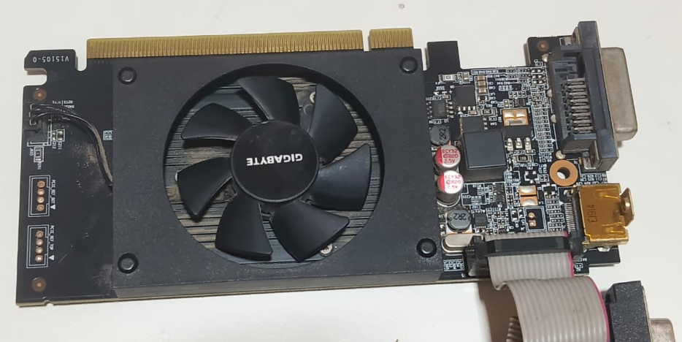

2. Identify All Expansion Slots and Their Purpose
1. PCIe x16 Slot
The PCIe x16 slot is mainly used for installing a dedicated graphics card (GPU).
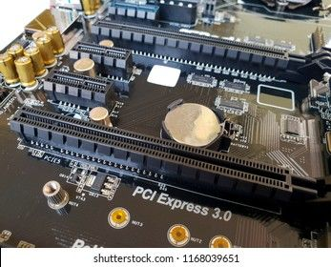
2. M.2 Slot
An M.2 slot is used for compatible M.2 storage devices, particularly NVMe SSDs.
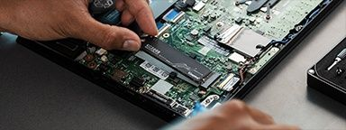
3. DIMM Slots
DIMM slots are used to install RAM modules.

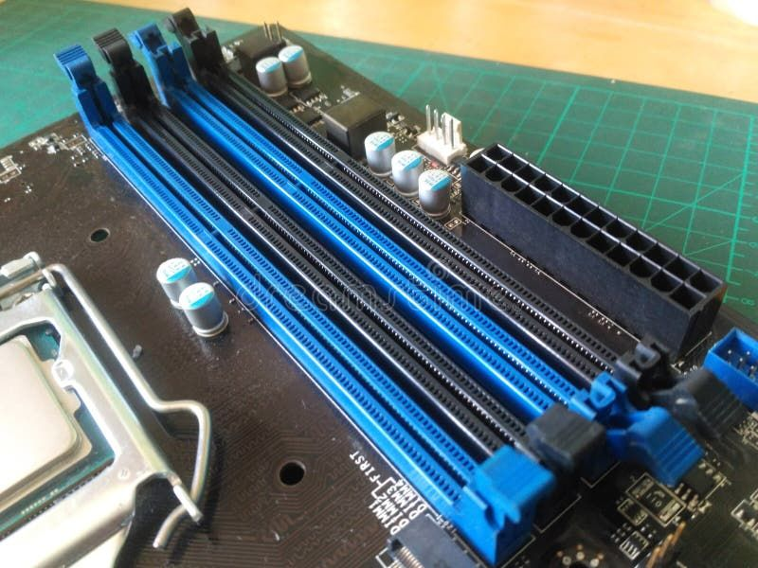

3.Identify the CPU Socket Type
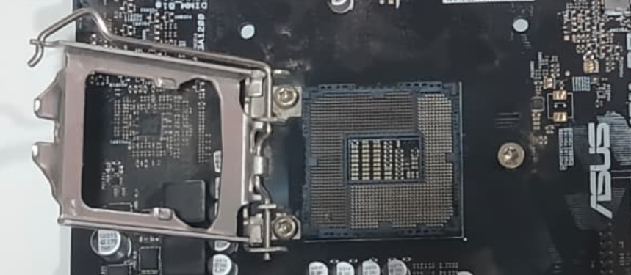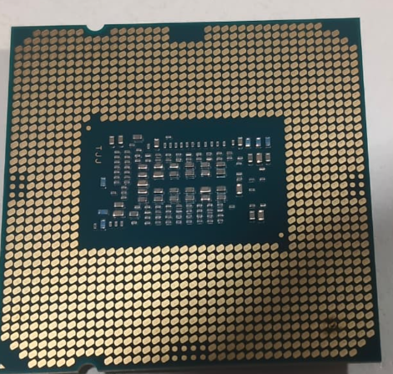
CPU Socket Type: Intel LGA (Land Grid Array) socket
CPU: Intel processor
Identification: The processor has contact pads on the underside, indicating an Intel LGA-type socket.
Compatible CPU Family: Depends on the exact LGA socket and motherboard. The motherboard's CPU support list should be checked before installation.

4. Photograph or Diagram the Motherboard with Labels:
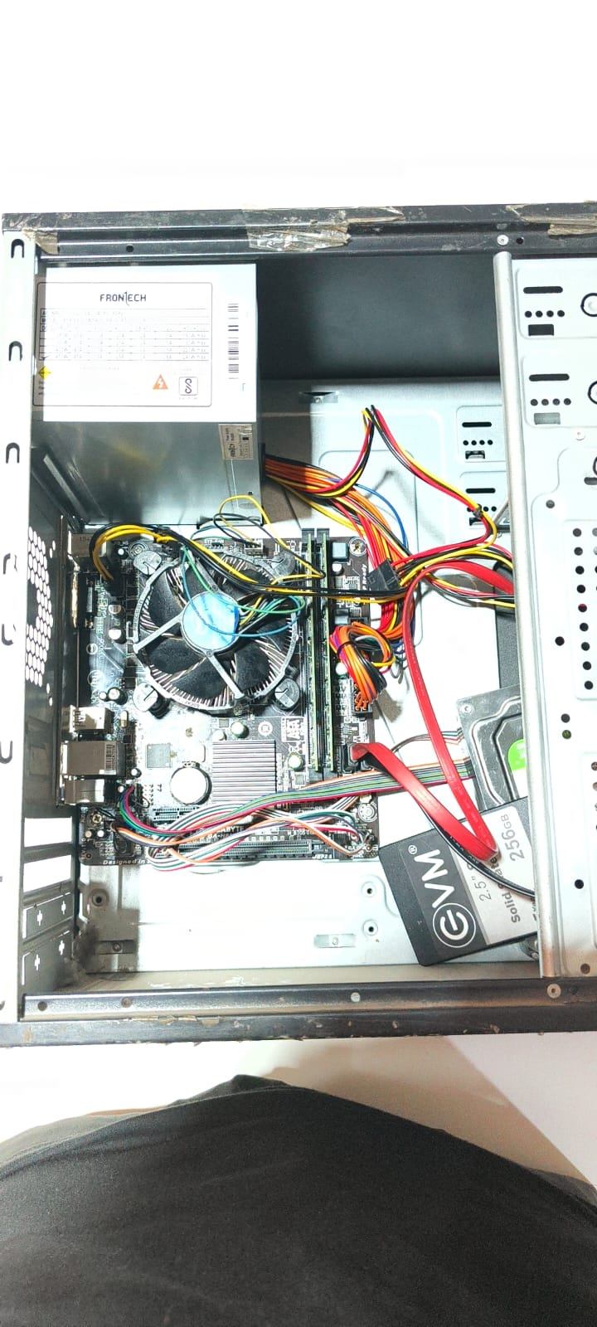

Task 3: RAM & Storage Installation
- Safely remove the RAM module, noting ESD precautions taken.
- Reinstall the RAM module correctly and confirm it is seated properly.
- Remove and reinstall the storage device, noting the connection type used (SATA/NVMe).
- Confirm both components are detected correctly after reinstallation.

3.1 Safely Remove the RAM Module
Procedure:
- Shut down the computer completely.
- Switch off the PSU and disconnect the power cable.
- Press the power button for a few seconds to discharge remaining power.
- Wear an anti-static wrist strap or use another proper ESD-safe method.
- Touch a grounded metal part of the case before handling the RAM.
- Locate the RAM module on the motherboard.
- Open the retaining clips on both sides of the RAM slot.
- Hold the RAM module by its edges and gently remove it.
- Avoid touching the gold contacts of the RAM.
- Place the RAM on an anti-static surface.
ESD Precautions Taken
- Power was disconnected before handling the component.
- Anti-static precautions were followed.
- RAM was held by its edges.
- Gold contacts were not touched.

3.2 Reinstall the RAM Module
Procedure
- Check the notch on the RAM module.
- Match the notch with the key in the motherboard RAM slot.
- Place the RAM module into the correct slot.
- Press down firmly and evenly on both ends.
- The retaining clips should automatically lock into position.
- Check that the RAM is straight and fully seated.
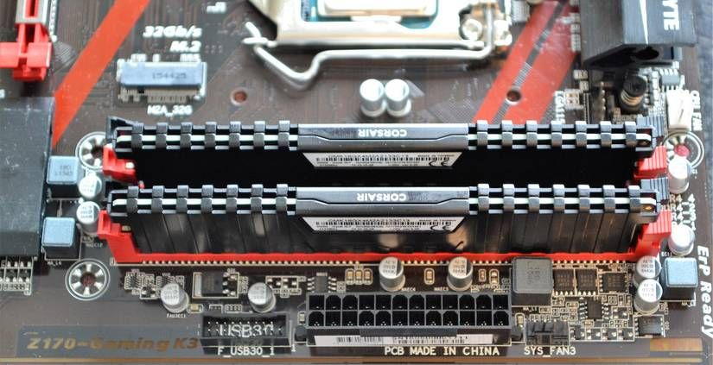

3.3 Remove and Reinstall the Storage Device
First identify the storage connection type.
If SATA Storage is Used
- Shut down the computer and disconnect power.
- Disconnect the SATA data cable from the motherboard.
- Disconnect the SATA power cable from the storage device.
- Remove the SATA SSD/HDD from its mounting location.
- Reinstall the storage device.
- Reconnect the SATA data cable.
- Reconnect the SATA power cable.
- Ensure both cables are firmly connected.
Connection Type: SATA
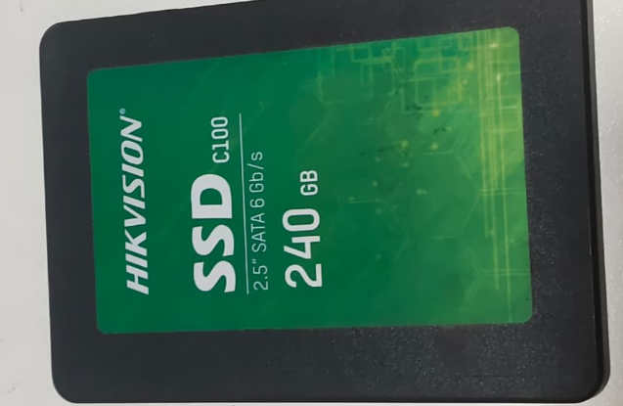

If NVMe/M.2 Storage is Used
- Shut down the computer and disconnect power.
- Locate the M.2 slot on the motherboard.
- Remove the M.2 mounting screw.
- Carefully remove the NVMe SSD.
- Insert the SSD into the M.2 slot at an angle.
- Press it down gently.
- Secure it with the mounting screw.
- Make sure the SSD is firmly installed.
Connection Type: NVMe / M.2
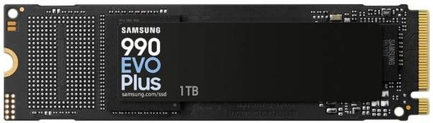

3.4 Confirm RAM and Storage Detection
After reinstalling both components:
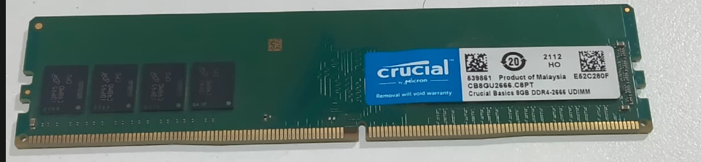
RAM Verification
- Connect power and start the computer.
- Enter BIOS/UEFI during startup.
- Open the memory/system information section.
- Check that the installed RAM capacity is displayed.
- Verify that the RAM module is detected.
Example: If an 8 GB RAM module is installed, BIOS should show approximately 8 GB RAM.
Storage Verification
- Enter BIOS/UEFI.
- Open the Storage, SATA, or NVMe information section.
- Check that the storage device is listed.
- Verify the drive model and capacity.
- After booting into Windows, open Disk Management or File Explorer to confirm the drive is accessible.

Task 4: Full Desktop PC Assembly
- Assemble the PC using the provided motherboard, CPU, RAM, storage, GPU, and PSU.
- Follow correct installation sequence and ESD/safety precautions throughout.
- Document each step with labeled photos or diagrams.
- Power on the system and confirm it passes POST successfully

Step 1: Install the Motherboard
Caption:
The motherboard was placed inside the cabinet and aligned with the mounting holes. It was secured using screws.

Step 2: Install the SMPS/PSU
Caption:
The SMPS was placed in its position and secured with screws. The power cables were kept ready for connection.

Step 3: Install the CPU and CPU Cooler
Caption:
The CPU was placed into the CPU socket and locked. Thermal paste and the CPU cooler were installed properly.

Step 4: Install the RAM
Caption:
The RAM module was inserted into the correct DIMM slot until the locking clips clicked into place.

Step 5: Install the HDD/SSD
Caption:
The HDD/SSD was placed in its mounting position and secured properly.

Step 6: Connect Storage Cables
Caption:
The SATA data cable was connected between the motherboard and HDD/SSD. The storage power cable was connected from the PSU.

Step 7: Install the GPU
Caption:
The GPU was inserted into the PCIe x16 slot and secured with a screw. The required GPU power cable was connected.

Step 8: Connect Front Panel and Fan Cables
Caption:
The power switch, reset switch, USB, audio, and case fan cables were connected to the motherboard.

Step 9: Connect Main Power Cables
Caption:
The 24-pin motherboard power connector and 8-pin CPU power connector were connected securely.

Step 10: Close the Cabinet and Test
Caption:
The side panel was attached, the power cable was connected, and the PC was switched on.

Section C: Mini Project

Workstation Deployment & Boot-Failure Diagnosis
Objective
The objective of this mini project is to inspect or build a workstation, identify possible causes of boot failure and hardware detection errors, verify component installation and compatibility, and prepare an installation and diagnostic report for ABC Solutions' computer lab.

1. Three Hardware Components to Check First When a PC Fails to Boot
Component | Why Check First? | What to Check
RAM | Incorrectly installed or faulty RAM can prevent POST and cause a blank screen. | Reseat RAM, check slots, test one module at a time.
CPU | The CPU is required for the system to execute the BIOS/UEFI startup process. | Check CPU seating, power connection, socket compatibility, and cooler installation.
Power Supply (PSU) | Without proper power, the motherboard and other components cannot start. | Check PSU switch, 24-pin motherboard cable, CPU/EPS cable, and PSU capacity.

2. Motherboard–CPU Compatibility
Motherboard and CPU compatibility is important because the processor must physically and electronically match the motherboard.
For the workstation assembled or inspected for ABC Solutions, I would verify:
- CPU socket type matches the motherboard socket.
- The motherboard supports the CPU family.
- The motherboard chipset supports the processor.
- The required BIOS/UEFI version supports the CPU.
- The motherboard supports the required RAM type.
- The CPU power connector and cooling solution are properly installed.
Example
If the inspected workstation uses an AMD Ryzen processor with an AM5 socket, the motherboard must have an AM5 CPU socket and a BIOS version that supports that particular Ryzen processor.

3. Verifying RAM and Storage Installation
- RAM Verification
Physical verification:
- Turn off the computer and disconnect power.
- Open the case.
- Check that the RAM module is correctly aligned with the slot notch.
- Press the module firmly until the retaining clips lock.
- Check the recommended RAM slots in the motherboard manual.
- If the PC does not POST, test one RAM module at a time.

BIOS/POST verification:
After powering on, enter BIOS/UEFI and check:
- RAM is detected.
- Correct total memory capacity is displayed.
- Memory speed is recognized.
- All installed modules are detected.
Example:
If two 8 GB RAM modules are installed, BIOS should normally show approximately 16 GB of RAM.

Storage Verification
Physical verification:
For a SATA SSD/HDD:
- Connect the SATA data cable to the motherboard.
- Connect the SATA power cable from the PSU.
- Ensure both connections are secure.
For an M.2/NVMe SSD:
- Insert the SSD into the correct M.2 slot.
- Secure it using the motherboard's mounting screw.
- Ensure the slot supports the type of M.2 drive being installed.

BIOS/UEFI verification:
BIOS should show the installed storage device under storage/NVMe/SATA information.
The operating system should also detect the drive after booting.
Expected verification
Component | BIOS/POST Should Confirm
RAM | Correct capacity and installed modules
SATA SSD/HDD | Drive model and capacity
NVMe SSD | NVMe drive model and capacity
CPU | Processor model and information
GPU | Display adapter detection, where applicable

4. Hardware Installation Checklist
No. | Installation Check | Purpose
1 | Verify motherboard, CPU, RAM and storage compatibility before installation. | Prevent incompatible hardware.
2 | Correctly install and lock the CPU and RAM. | Prevent POST and detection failures.
3 | Connect the 24-pin ATX and CPU/EPS power cables securely. | Ensure proper motherboard and CPU power.
4 | Correctly connect SATA data and power cables or install the M.2 SSD properly. | Ensure storage detection.
5 | Install the CPU cooler and connect its fan to the correct header. | Prevent CPU overheating.
6 | Check motherboard standoffs and cable connections before powering on. | Prevent short circuits and loose connections.
7 | Enter BIOS/UEFI after assembly and verify CPU, RAM and storage detection. | Confirm successful installation.
8 | Run POST and check diagnostic LEDs/beep codes for errors. | Identify hardware problems early.

5. Technical Justification for Using SSD Instead of HDD
For the ABC Solutions computer lab, SSDs are more suitable than traditional HDDs for modern office workstations.
SSD | HDD
Uses flash memory | Uses spinning magnetic disks
Faster boot time | Slower boot time
Faster application loading | Slower application loading
No moving mechanical parts | Contains moving parts
Better resistance to physical movement | More sensitive to physical shock
Quiet operation | Produces mechanical noise
Better overall responsiveness | Lower performance
Why SSD is suitable for the lab
Office workstations may be used for:
- Windows startup
- Microsoft Office applications
- Web browsers
- Programming tools
- Database applications
- File management
- Multiple applications at the same time
An SSD provides faster booting, quicker application loading, and better overall system responsiveness. Since the computer lab will have many workstations and users may frequently start applications and access files, SSD storage can provide a smoother working experience.

Section D: AI-Augmented Learning

STEP 1: BUILD WITH AI
Desktop PC Boot-Failure Troubleshooting Checklist
Scenario: ABC Solutions has assembled new desktop PCs. Some systems fail to start or show hardware detection errors.

On-Site Troubleshooting Flow
START → PC fails to boot
1. Ensure Safety and ESD Protection
- Turn off the PC and disconnect power before opening the case.
- Use an anti-static wrist strap or appropriate ESD precautions.
- Do not work inside the PC while it is powered.
2. Check PSU and Power Connections
- Confirm the PSU switch is ON.
- Check the power cable and wall connection.
- Check the 24-pin motherboard power connector.
- Check the 4/8-pin CPU power connector.
- Confirm the PSU has sufficient wattage.
If no power: troubleshoot the PSU/power connections first.
3. Check Motherboard
- Check motherboard diagnostic LEDs or beep codes.
- Look for loose connections or visible damage.
- Confirm motherboard standoffs are correctly positioned.
- Verify the CPU is compatible with the motherboard.
- Check whether the BIOS supports the installed CPU.
If motherboard/CPU error appears: correct the installation or compatibility issue.
4. Check RAM
- Power off the PC.
- Remove and reseat the RAM.
- Ensure the RAM is installed in the recommended slot.
- Test one RAM module at a time if necessary.
- Check that the retaining clips are locked.
If RAM is not detected: reseat or test the RAM.
5. Check Storage
- Check SATA data and power cables for SATA drives.
- For NVMe, check that the M.2 SSD is properly inserted and secured.
- Enter BIOS/UEFI and check whether the storage device is detected.
If storage is not detected: check connections, slot compatibility, and the drive.
6. Perform Minimal Hardware Test
- Disconnect unnecessary USB devices and expansion cards.
- Keep only essential components: motherboard, CPU, one RAM module, PSU and display output.
- Try starting the system again.
7. Check POST/BIOS
- Confirm the system reaches POST.
- Enter BIOS/UEFI.
- Verify CPU, RAM and storage information.
- Check for hardware error messages.
8. Test the System After Correction
- Reconnect components one at a time.
- Boot the system after each major correction.
- Confirm that all hardware is detected correctly.

Simple Decision Flow:
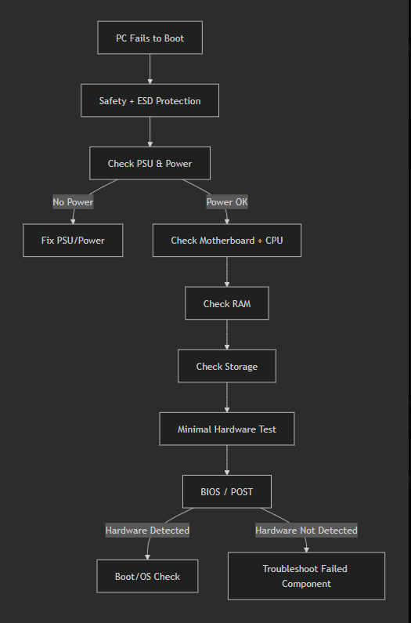

Application to ABC Solutions
In the ABC Solutions scenario, the reported problems were boot failures and hardware detection errors.
The checklist would identify the problem as follows:
- If the PC had no power, Step 2 would identify a PSU or power-connection problem.
- If the PC failed POST because RAM was incorrectly installed, Step 4 would identify and correct the RAM installation.
- If the storage device was missing from BIOS, Step 5 would identify the storage connection or compatibility problem.
- If an incompatible CPU was installed, Step 3 would identify the motherboard-CPU compatibility issue.
Therefore, the checklist prioritizes physical and power-related causes before software troubleshooting, which is appropriate for a newly assembled computer.

STEP 2: TEST & DEBUG WITHOUT AI
Manual Review of the AI-Generated Checklist
After reviewing the troubleshooting checklist generated by ChatGPT, I manually checked the steps to identify any missing, incorrectly ordered, or unsafe instructions.
Issue Identified
I found that ESD and electrical safety precautions must be clearly performed before checking or reseating internal hardware components.
Correction Made
I corrected the checklist by making Safety and ESD Protection the first step.
Corrected Procedure
- Shut down the computer.
- Turn off the PSU and disconnect the power cable.
- Use an anti-static wrist strap or follow proper ESD precautions.
- Open the computer case only after disconnecting power.
- Check and reseat the RAM, storage, cables, and other components.
- Continue with PSU, motherboard, CPU, RAM, and storage troubleshooting.

